Chapter 7, Problem 67.

If v(0) = 5 V, find v_{o}(t) for t > 0 in the op amp circuit in Fig. 7.132.
Let R = 10 kΩ and C = 1 μF.

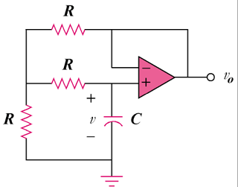

Figure 7.132
For Prob. 7.67.

